

Cariboo-Chilcotin School District
2020-2021 School Plan for Learner Success

School Name: École Nesika Elementary School

Ministry of Education Framework: A shared commitment to improve student success, equity and inclusivity of learning outcomes for all students with a particular focus on Indigenous students, children and youth in care and students with disabilities or diverse abilities.
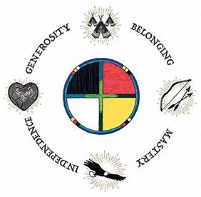
Circle of Courage: (Brendtro, Brokenleg, Van Bockern, 1990) emphasizes the four growth needs of all children: Belonging, Mastery, Independence, and Generosity. This model informs teaching and educational decision-making in the District and is expected to be considered in school planning for learner success.
Collection of Evidence
After reviewing data input into the Power BI collection program, we have identified a need for collection of authentic evidence at every grade level, particularly grades 4+. We wonder if when letter grades begin at grade 4; achievement data becomes less reflective of authentic student progress? We believe there is a need to change both the way we code assessment, and the way we practice assessment and reporting in our classrooms. As such, we see an opportunity to make changes to these practices:
- In grades 1-6, the Four-Point Provincial Proficiency Scale will be used to communicate student progress in all areas of learning.
- Descriptive feedback including strength-based written comments and/or documented conversations that describe individual student progress and identify specific goals to support further student growth in Fresh Grade.
Intellectual Development
Educational Outcome 1: Students will meet or exceed literacy expectations for each grade level
2019-2020 Results:
- Percentage of students meeting or exceeding literacy expectations:
2020-2021 LITERACY Goals and Focus Areas:
- Improve the number and percentage of students grades 1-3 meeting or exceeding expectations in literacy
- Improve the number and percentage of Indigenous students grades 1-3 meeting or exceeding expectations in literacy
Strategies and Structures:
- Actions for Enhancing Student Learning and Experience
  - School wide focus on explicitly teaching reading strategies (identified from EPRA/DART as a need)
  - Supplemental reading support (Literacy lead teacher – Mrs. Johnson) for targeted students when applicable
  - Phonological awareness screening and concepts of print for all primary students in K-3 with literacy lead teacher and school speech and language pathologist (Mrs. Johnson and Ms. Lundeen). Beginning of a development of K-3 learner profile project.
- Actions for Enhancing Staff Capacity & Learning
  - Whole staff review of ELA & FILA curriculum and provincial performance standards
  - Whole staff review of EPRA/FEPRA/DART results and report card marks
  - School literacy lead attending Faye Brownlie Pro-D and sharing with staff
  - School literacy lead holding monthly meetings to discuss best reading strategies/approaches with classroom teachers
Educational Outcome 2: Students will meet or exceed numeracy expectations for each grade level
2019-2020 Results:
- Percentage of students meeting or exceeding numeracy expectations:
2020-2021 NUMERACY Goals and Focus Areas:
- Improve the number and percentage of students grades 1-3 meeting or exceeding expectations in numeracy
- Improve the number and percentage of Indigenous students grades 1-3 meeting or exceeding expectations in numeracy
Strategies and Structures:
- Actions for Enhancing Student Learning and Experience
  - School focus on Thinking Classrooms practices (group led by Mrs. Bos)
  - Small group in-class support for identified gaps in number sense or extension of learning, as needed
  - Targeted learning rounds in grade 3/4 (led by Mr. Williams)
- Actions for Enhancing Staff Capacity & Learning
  - School focus on Thinking Classrooms practices (group led by Mrs. Bos)
  - Collecting and analyzing information from FSA and report card marks to see if there are specific areas of focus requiring further support, especially for Indigenous students.
  - Explore First Peoples Principles of learning in practice for math using the FNESC Math First Peoples planning document and the “Wild Math” curriculum resource set.
  - School numeracy lead (Mrs. Bos) attending Peter Liljedahl Pro-D and sharing with staff
  - School numeracy lead holding monthly meetings to discuss thinking classroom strategies with classroom teachers

Human and Social Development
Educational Outcome 3: Students will feel welcome, safe and connected to their school
3. 1 Attendance
2019-2020 Results:
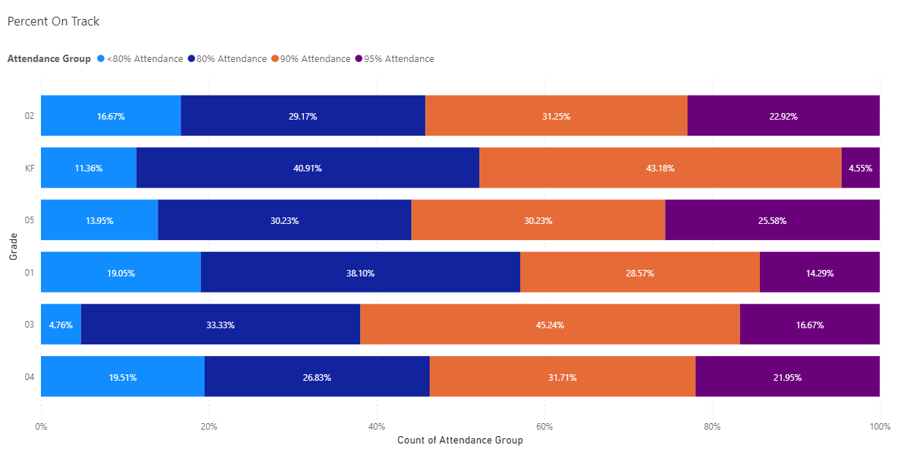
- Percentage of students attending 80% or greater end of June 2020

Goals and Focus Areas:
- All students attending 80% or greater end of June 2021
Strategies and Structures
- Actions for Enhancing Student Learning and Experience
  - Staff members will greet and welcome all students by name everyday
  - Monthly review of student attendance with all staff with commitment for follow up
  - Regular positive communication with parents regarding school attendance

- Actions for Enhancing Staff Capacity & Learning
  - MyEd training for teachers for proper attendance input (November)
  - Regular check-ins with families by classroom teachers

3.2 Connection
2019-2020 Results
- Percentage of students in grades 4 who report feeling welcome in their school during 2019-2020
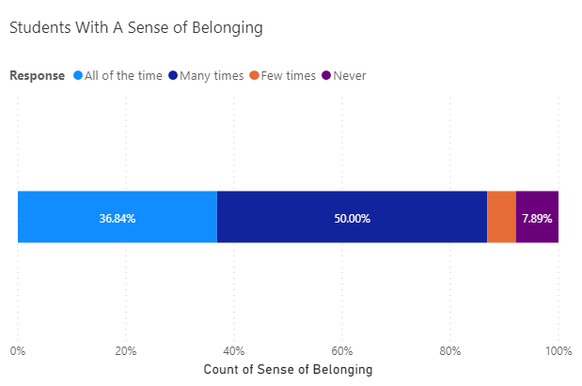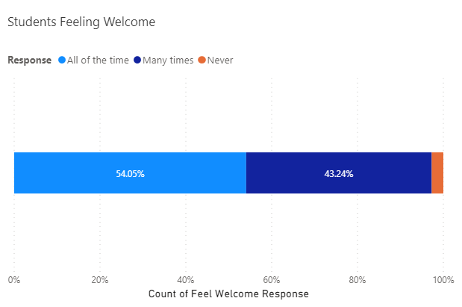
Goals and Focus Areas
- Increase number of students in all grades feeling welcome and connected to École Nesika Elementary
- Increase the number of students in our school who always feel like they belong at our school
Strategies and Structures
- Actions for Enhancing Student Learning and Experience
  - Increased connection throughout school to First Nations culture & language – every class receiving at least one block of this learning every week
  - Increased focus on place-based learning
  - Increased focus on connecting to core competencies
  - Positive newsletter messages, student incentives, positive class meetings, regular positive student recognition, student leadership theme days, positive calls home
  - Personalized learning and regular support from all staff
  - Continue building connections between French immersion and English classrooms
- Actions for Enhancing Staff Capacity & Learning
  - Expand Student Satisfaction Survey for all students and discuss results
  - Highlight and celebrate French immersion, place-based learning and First Nations culture and language learning as it happens using visible areas in the school and traditional and social media
  - Staff continue to explore Self-Regulation (Shanker)
  - Continue to implement Trauma Informed Practices for all learners

School Team Meeting Schedule:
School Team Project Leaders: Mr. C. Williams (Principal), Mrs. H. Zurak (Vice-Principal), Mrs. K. Johnson (Learning Support/Resource and Literacy Lead Teacher), Mrs. A. Bos (Professional Learning and Numeracy Lead Teacher) and Mme N. Ratko (French Immersion Lead Teacher)
Sep-Nov: Introduce updated school planning model. Review results from 2019-2020 school year and fall assessments as a staff. Identify student focus groups and strategies and document in school plan.
November: Assessment and Reporting teaching staff meeting to clarify vision, goals and school plan for assessment and reporting.
Dec: Review term 1 report card data as a staff. Revisit focus areas of school plan. Celebrate success and modify focus areas as required.
Jan-Feb: Review FSA data alongside report card marks and assessments (triangulation). Celebrate successes and adjust strategies as required.
February: Assessment and Reporting teaching staff meeting to reinforce vision, re-visit goals and school plan for assessment and reporting.
Mar-Apr: Review term 2 report data as a staff. Revisit focus areas of school plan. Celebrate success and modify focus areas as required.
May-Jun: Complete district assessments including EPRA/DART and School Wide Write. Review results and compare alignment with report card data collected for term 2. Review student learning survey results and plan response.
Jun: Review all available data for school for 2020-2021 school year.
Ongoing:
- School Plan for Learner Success as standing item on staff meeting agenda
- School Team Project Leaders meet monthly to compare alignment and report out
- Literacy and Numeracy groups meeting to review successes and challenges

Glossary:
ELA – English Language Arts
EPRA / DART –Performance-based reading assessments, designed in British Columbia, by cohorts of British Columbia educators, in response to teachers’ questions about how best to use assessment information to guide their reading instruction.
Faye Brownlie – One of BC’s most sought after literacy and learning experts. She works in staff development in BC, nationally and internationally.
FESL – Framework for Enhancing Student Learning: Ministry framework for ensuring shared commitment to improve student success, equity and inclusivity of learning outcomes for all students.
FSA – Foundation Skills Assessment: Provincial assessment at the grade 4 and 7 level for Reading, Writing, and Numeracy.
SBT – School Based Team: A team led by the principal that assists classroom teachers to develop and implement instructional and/or management strategies and to coordinate support resources for students.
School Wide Write – A SD 27 school-wide writing assessment completed by grades 1-9 every fall and spring.
Thinking Classrooms (Peter Liljedahl) – Dr. Peter Liljedahl is a Professor of Mathematics Education in the Faculty of Education and an associate member in the Department of Mathematics at Simon Fraser University in Vancouver, Canada. A “Thinking classroom” is a classroom that is not only conducive to thinking but also occasions thinking, a space that is inhabited by thinking individuals as well as individuals thinking collectively, learning together, and constructing knowledge and understanding through activity and discussion. It is a space wherein the teacher not only fosters thinking but also expects it, both implicitly and explicitly.

